To log in to any wordpress site, you will navigate to the domain followed by /wp-admin

For example: [www.snapcats.org/wp-admin](http://www.snapcats.org/wp-admin)

**This will lead to a login page, such as:**

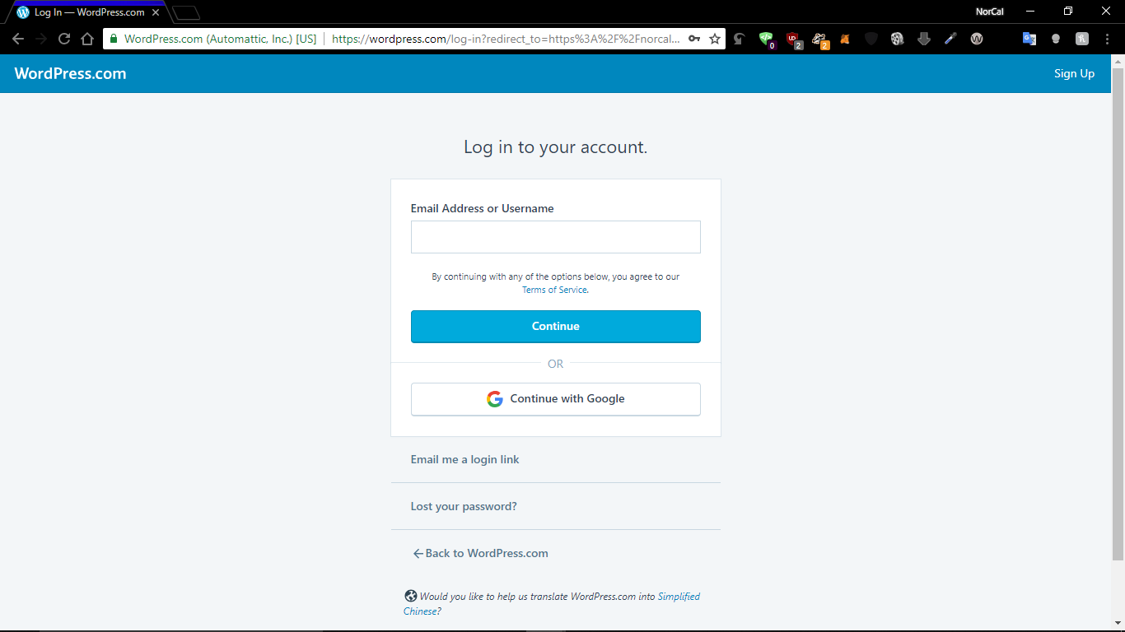

**Once you log-in, you will be directed to your dashboard, which will appear similar to this:**

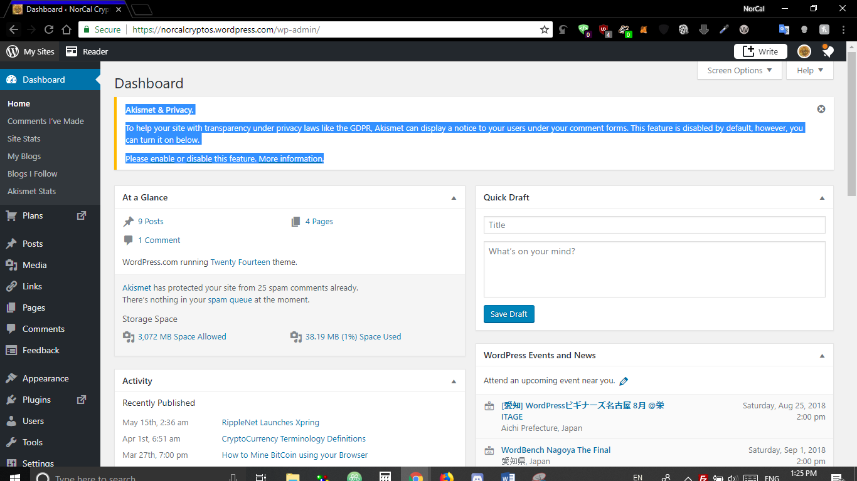

**To make a new post, click on the “Posts” link on the left side-bar, then click “Add New”**

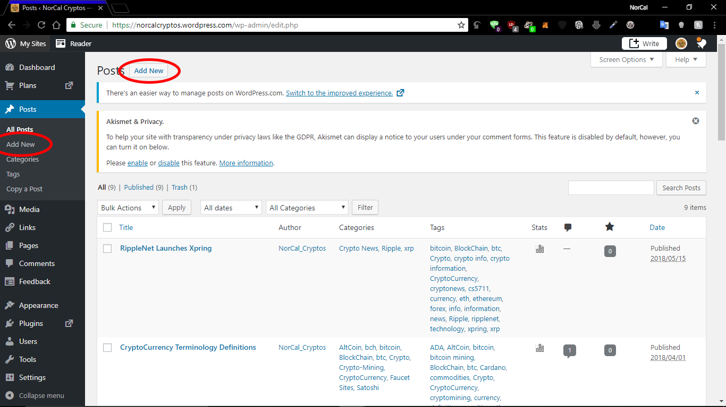

**From here you can easily add a new post which will show up in the “blog” (Darryl’s Den) section of your page**

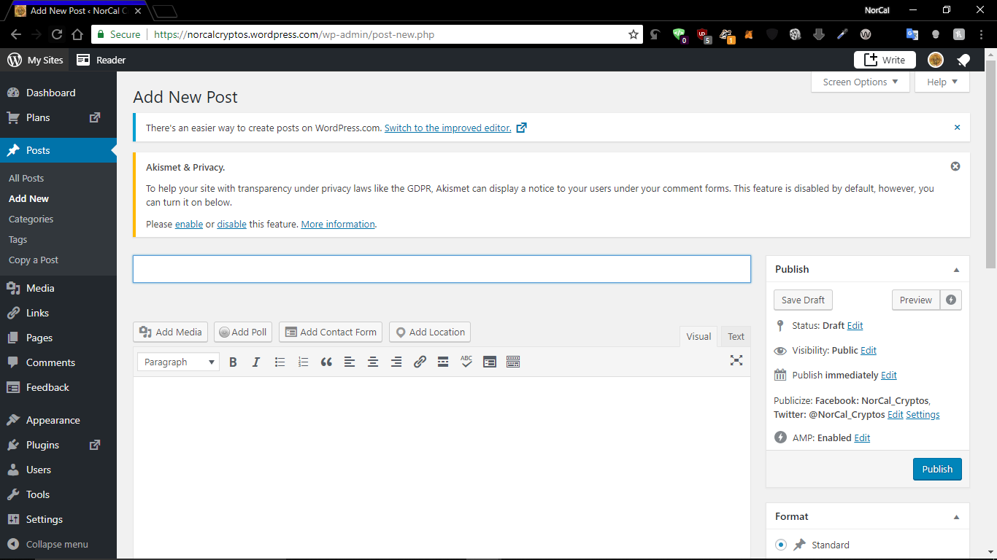

**Make sure to set the format, categories, add tags, and set a featured image. This will add organization to the post and help search engines to index your posts so they show up in search results.**

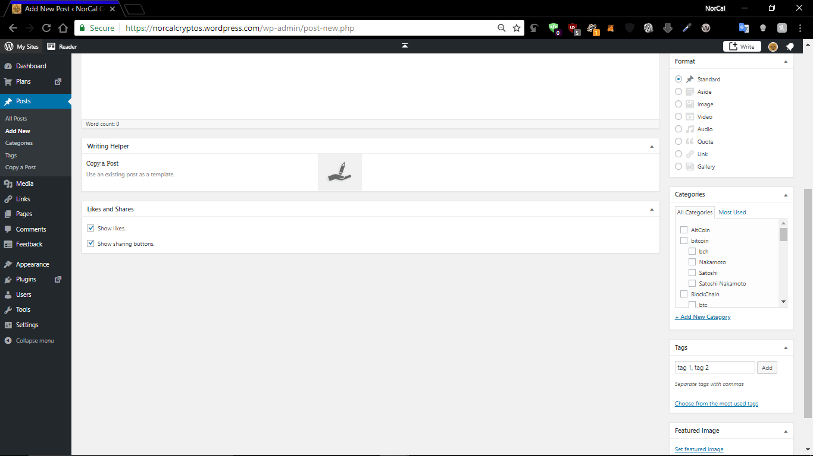

**To add a new page to your websites structure, then click on the “Pages” link on the left side-bar, then click “Add New”.**

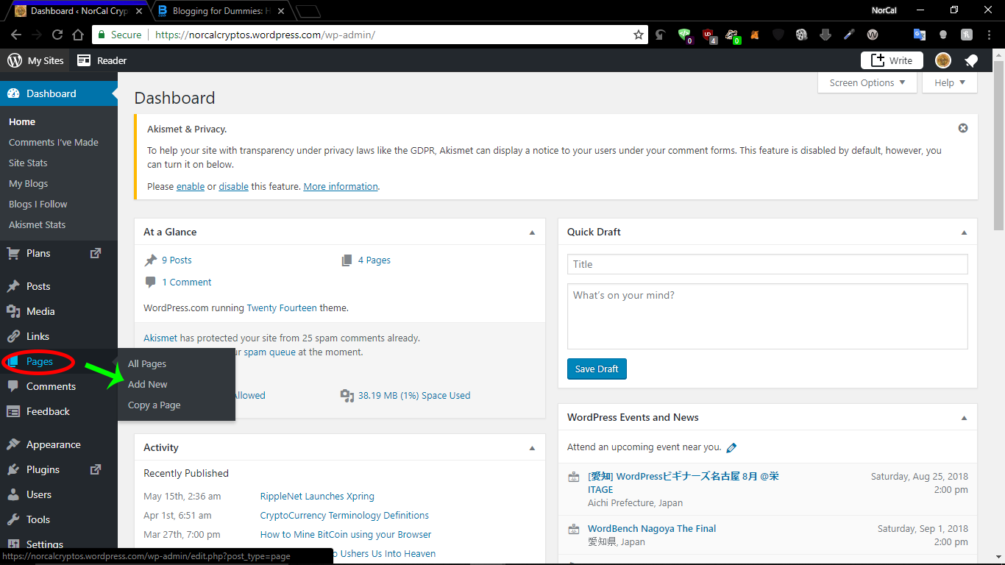

**Adding a new Page is very similar to writing a new blog post, with just a few minor changes. There are no formats/tags/categories with Pages, but Pages can be set to be “under” other pages to create a structure to your website.**

**As in this example, you can see that “Faucet Sites Listing” is under “Crypto Faucets”. This can help organize your menus, and creates a URL where each sub-page is listed under its parent pages**

**Such as:**

https://norcalcryptos.wordpress.com/crypto-faucets/all-faucets/

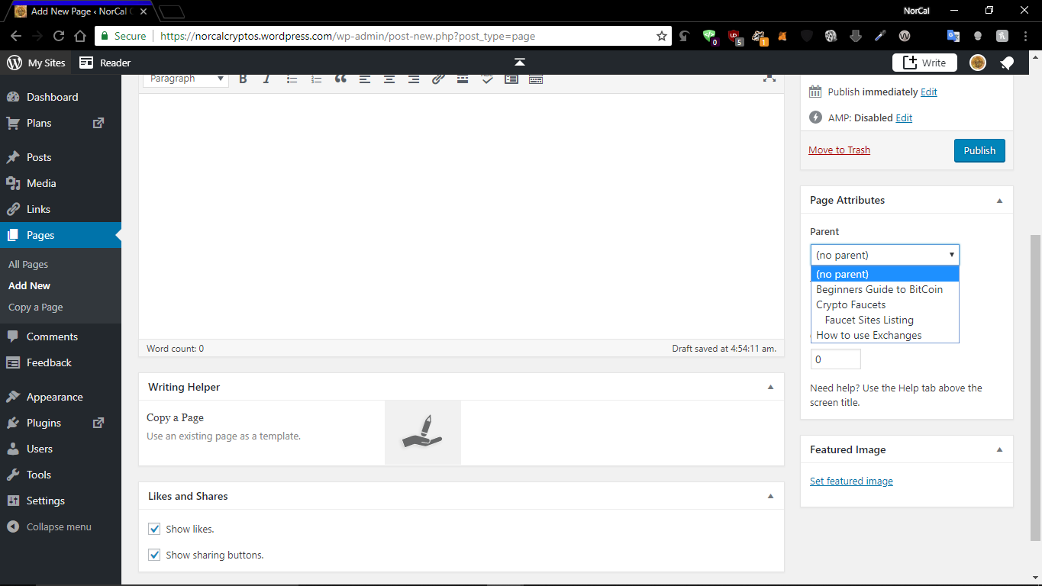

**To view your sites statistics and viewer count, click on the “Dashboard” button the left side-bar, then click “Site Stats”**

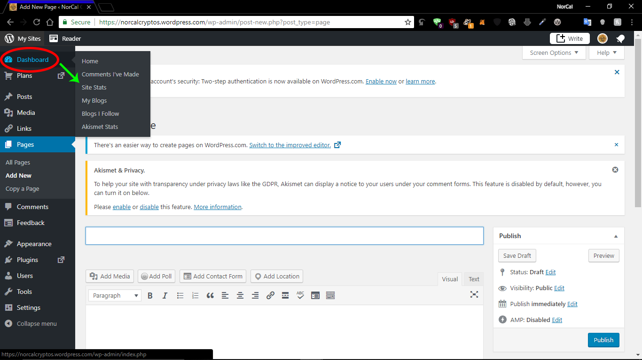

**If you add new pages and want them listed on your menus, then you can edit your menus structure by clicking “Appearance” on the left side-bar, then clicking “Menus”**

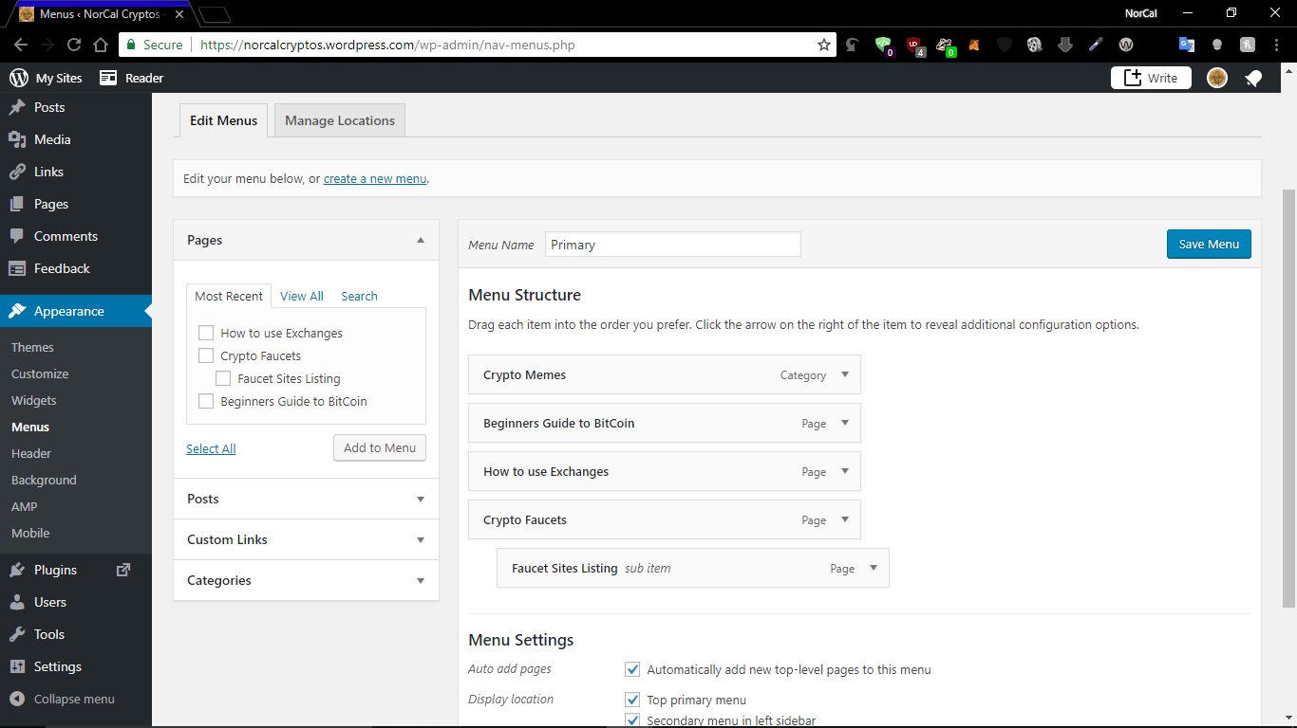

This was just a brief introduction on how to use WordPress. If you have any more questions, you are welcomed to email Joshua or Evalyn.

**Additional guides/tutorials/resources:**

Writing posts:

<https://codex.wordpress.org/Writing_Posts>

Lessons:

<https://codex.wordpress.org/WordPress_Lessons>

Blogging:

<https://www.bloggingceo.com/how-to-start-a-blog/#step-4-install-a-wordpress-blog-now>

<http://www.wpbeginner.com/start-a-wordpress-blog/>

More resources:

<https://www.elegantthemes.com/blog/resources/the-best-wordpress-tutorial-websites-that-every-wordpress-user-should-know-about>